**INVENTORY MANAGEMENT SYSTEM**

**Project Report**

**-Group:08**

**Project Title:**Inventory Management System

**Brief Description: INVENTORY MANAGEMENT SYSTEM**

Create a database project for a small scale company’s inventory management. In this project,

we create tables for:

1. ***suppliers*** with supplierID, phoneNumber and other relevant attributes,

2. ***purchases*** with productID, supplierID, datePurchased and other relevant attributes,

3. ***products*** with productID, productType and other relevant attributes, and

4. ***orders*** with orderID, Name, orderDate, shippedDate and other relevant attributes.

**Synopsis**

**Aim/Objective:**The objective is to create an inventory system for small scale businesses that can track and display the product data efficiently.and to minimize investment in inventory at minimum and to get maximum profit

**INVENTORY MANAGEMENT SYSTEM**

 It refers to the process of ordering, storing and using a company's inventory. This includes the management of raw materials, components and finished products, as well as warehousing and processing such items.

For companies with complex supply chains and manufacturing processes, balancing the risks of inventory gluts and shortages is especially difficult. To achieve these balances, firms have developed this inventory management system

**INTRODUCTION:**

It is a computer-based system for tracking the inventory levels , order , sales and it can be also used by the manufacturing industry to create a work order, bill of materials and other product related document. This Inventory management software is used to avoid the product overstock and outages .

**ADVANTAGES:**

The two main advantages by using this inventory management system are

1)To keep the inventor sufficiently high level to perform production and sales activities smoothly

2) To minimize investment in inventory at minimum and to get maximum profit

**SCOPE:**

scope is that who the way the inventory information is used. A manufacturer of durable goods may use inventory information to control the costs of raw materials and maximize margins while food manufacturer give the priority to fast turnover of inventory to ensure the freshness and by this we can understand that it’s the way that inventory information is used

**GOAL:**

The goal of this project is that developing a system which is user friendly and it is easy for user to use it and by using this software we mange the inventory properly and minimum investment and then get the maximum profit on the investment.

**Details Handled:**

In this project, we have four table - suppliers, purchases, products and orders.

Products and Orders are the only tables that the workers interact with when a customer to the

business is buying a product. Suppliers and Purchases are the only tables that the workers

interact with when buying products from other medium or large scale companies.

Each product (for example books) bought in bulk order will be individually given an SKU (Stock

Keeping Unit). Unique products will have unique SKUs. A product of same type (for example all

the *hardcover* books Dracula by Bram Stoker will have a unique SKU and all the *paperback*

books Dracula by Bram Stoker will have a unique SKU).

**Sample Scenarios:**

When a customer to the business buys a product, the worker from the

business will enter the order details into the frontend to update the tables. The frontend will thenalso show the remaining number of the same product.

**Application Uses:**

Any small scale business with a few customisations can use this project to

keep track of their products.

**Project Flow Necessary steps :**

1. Database was created using MySQL.

2. Websites were created using HTML and CSS.

3. The connection between database and websites was made using PHP.

**ER Diagram:**

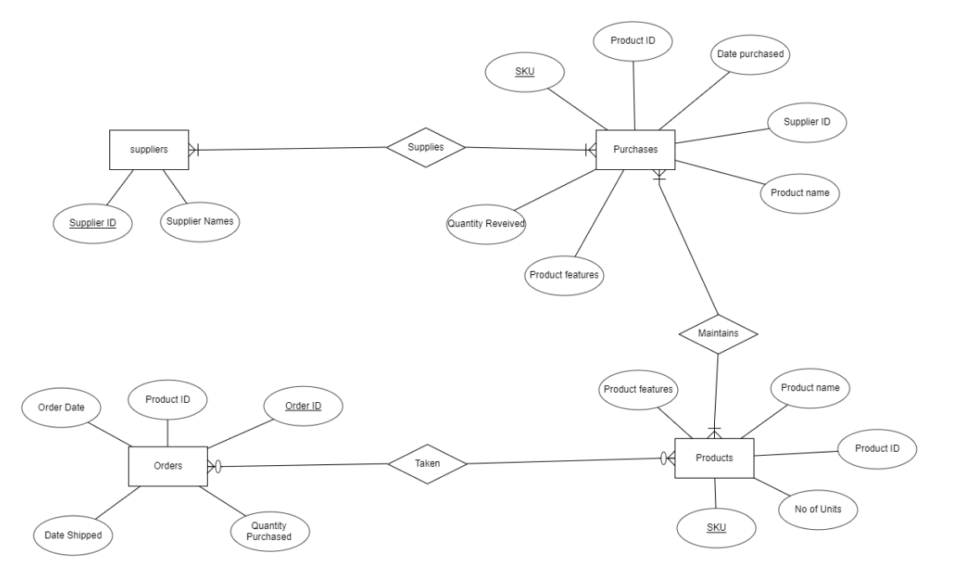

**Conclusion :**

The main purpose of this project is to make the inventory management of small scale businesses easy.

**ScreenShots:**

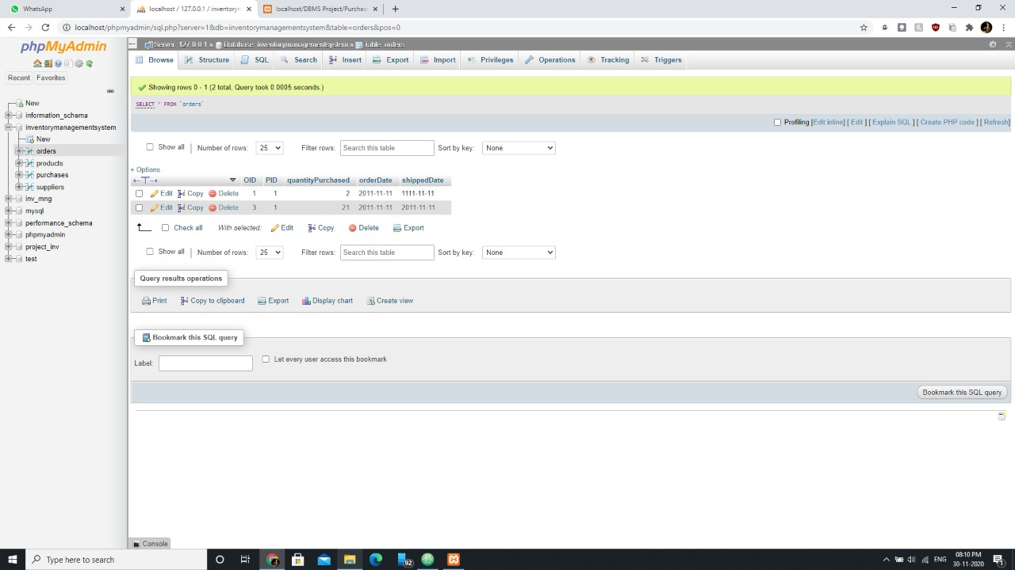

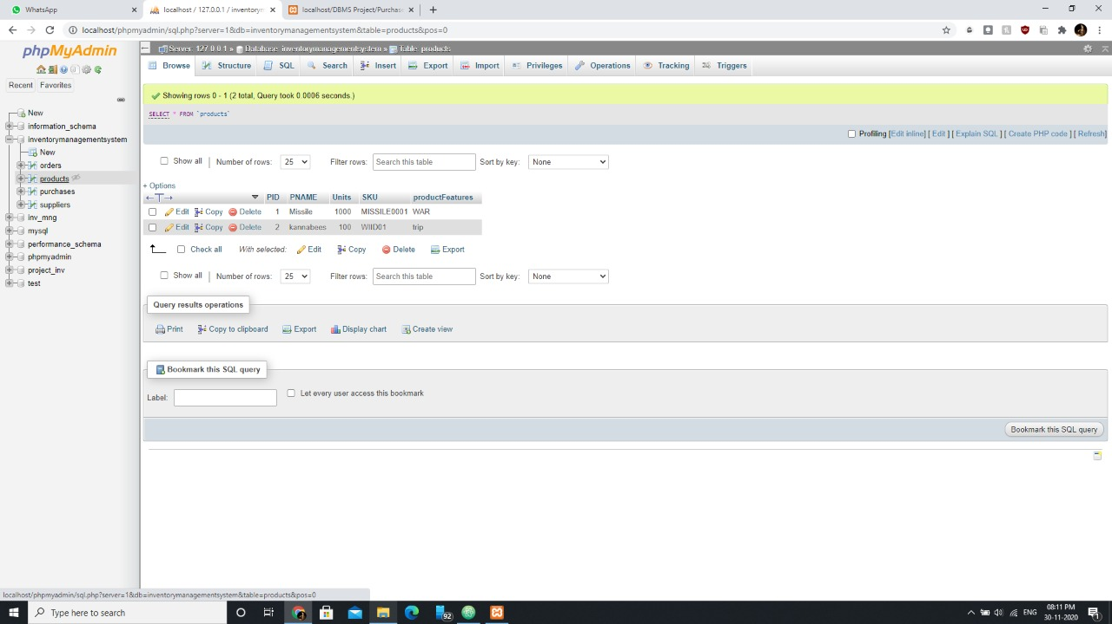

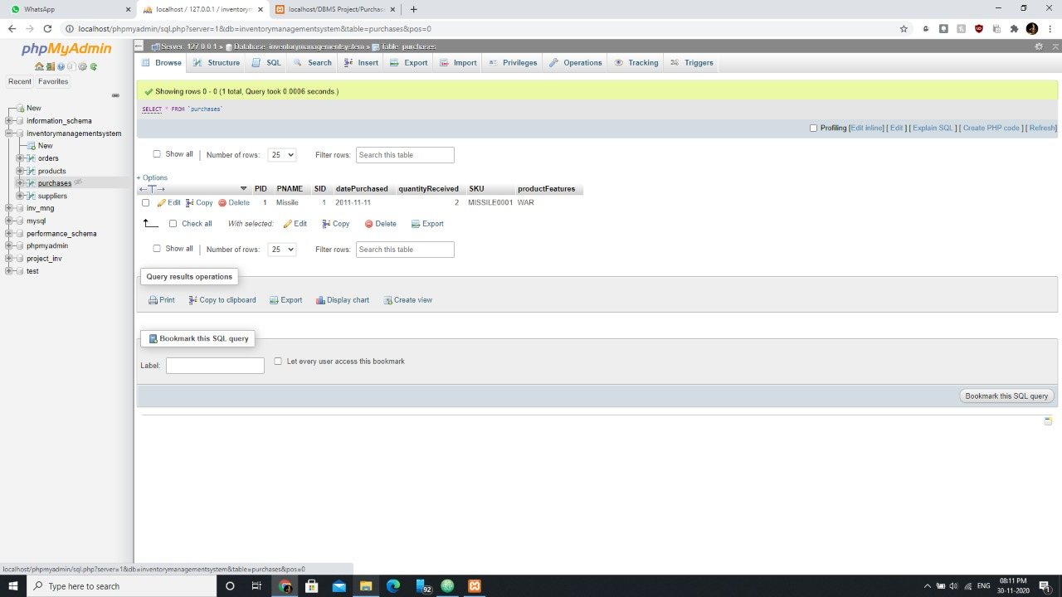

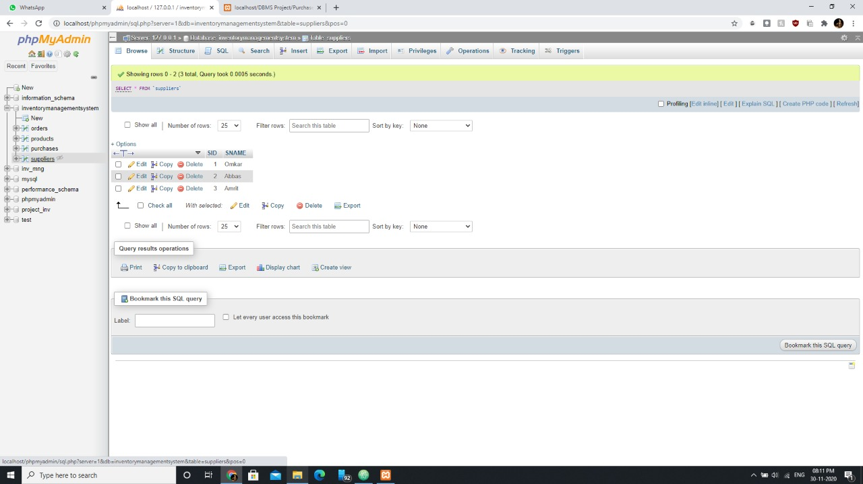

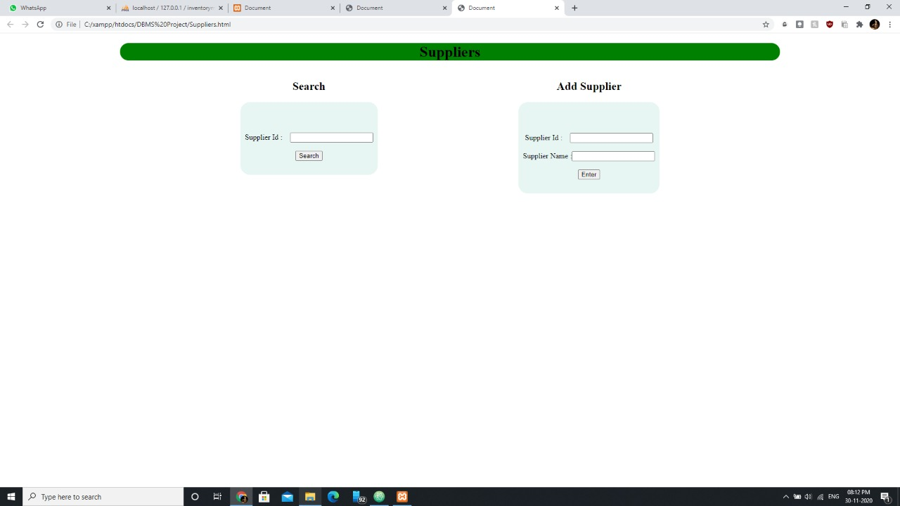

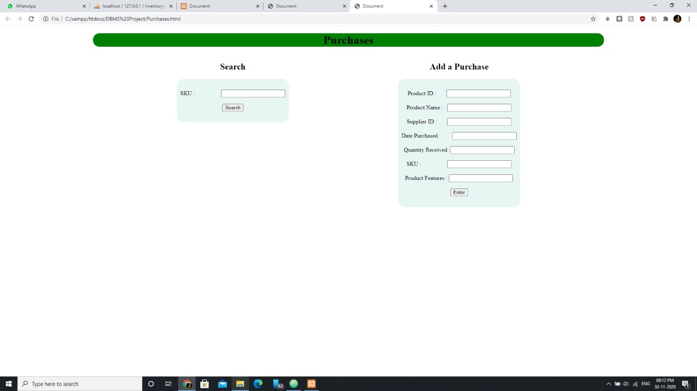

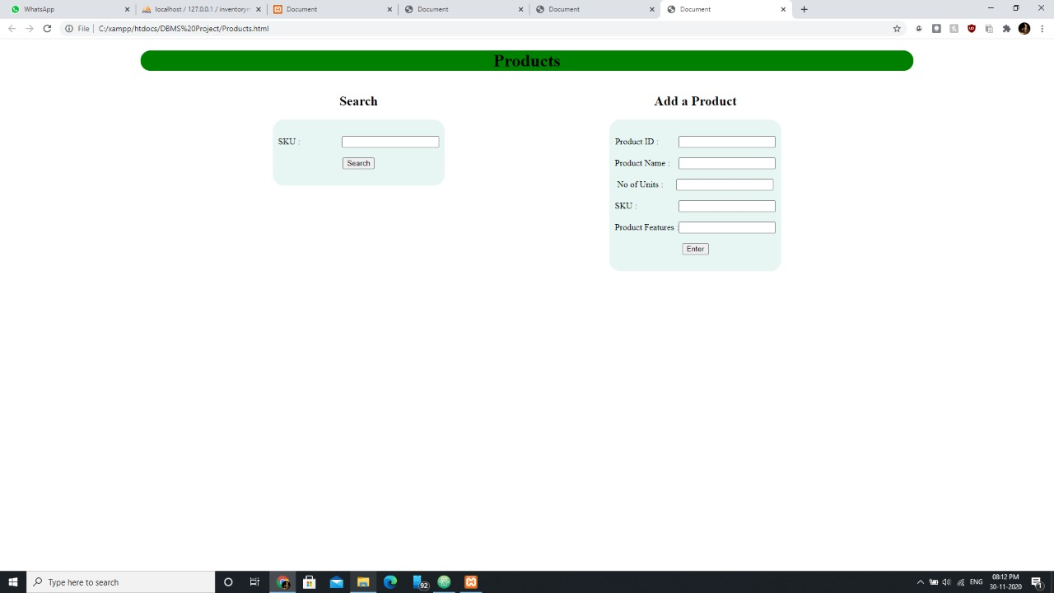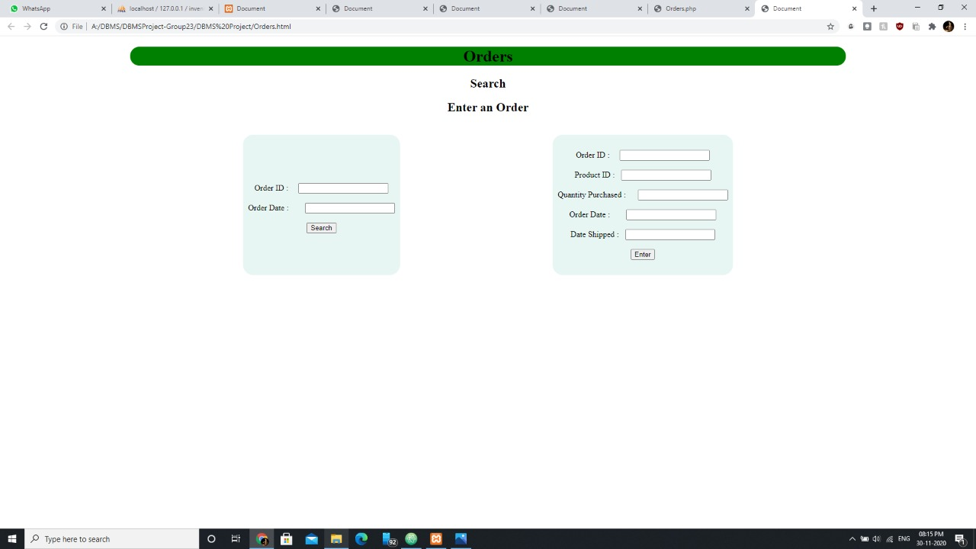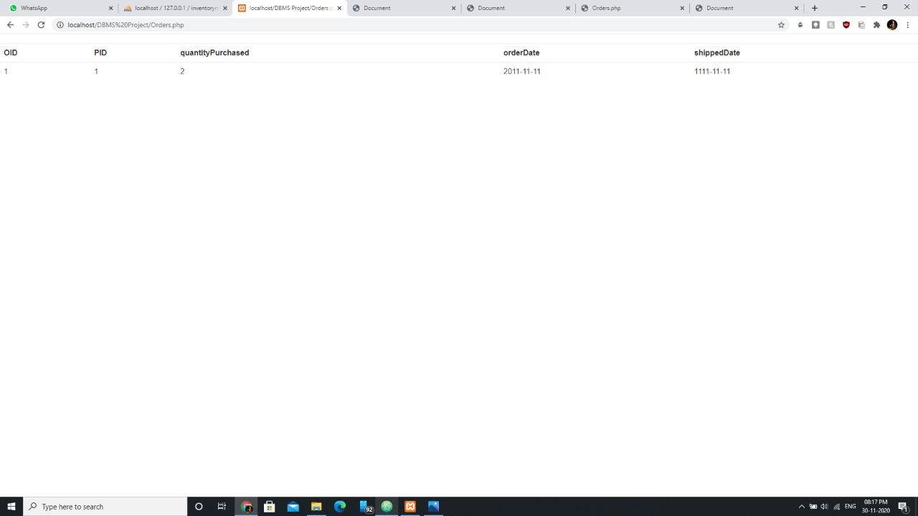

**Links to Refer:**

1. https://www.freecodecamp.org/news/making-an-awesome-inventory-management-applic

ation-in-php-and-mysql-from-start-to-finish-90bc5996680a/